Joseph Silva Jr.

07/03/21

CS 340 – Assignment: 1

SNHU

**Commands**

* **cd /usr/local/datasets**
* **mongoimport --port 53139 --db enron --collection emails ./enron.json**
* **User**

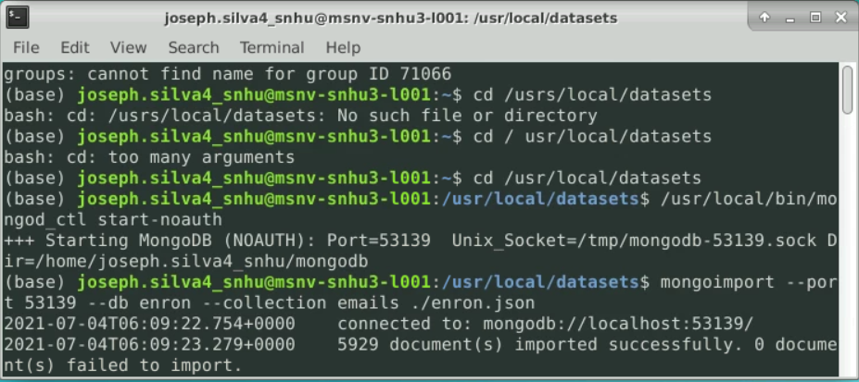

* **Execute the mongo command to start the mongo shell**

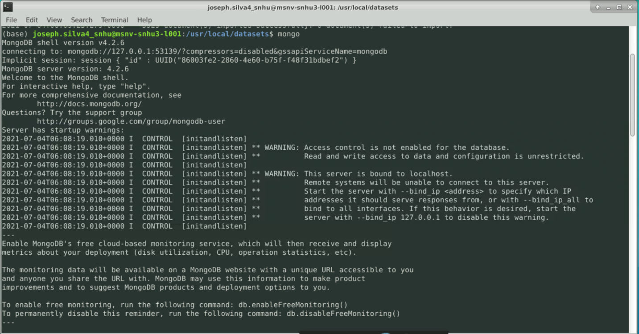

* **show dbs**

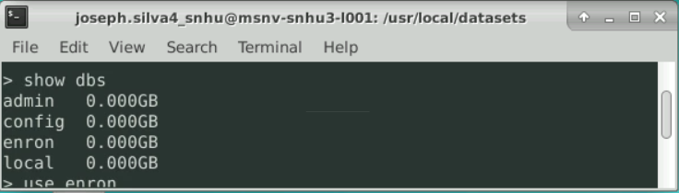

* **use enron**

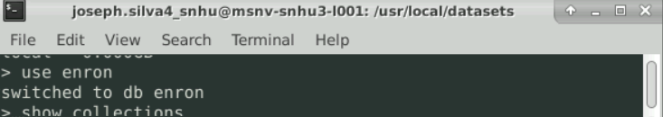

* **show collections**

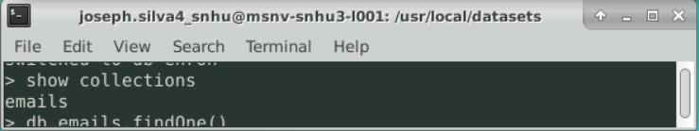

* **db.emails.findOne()**

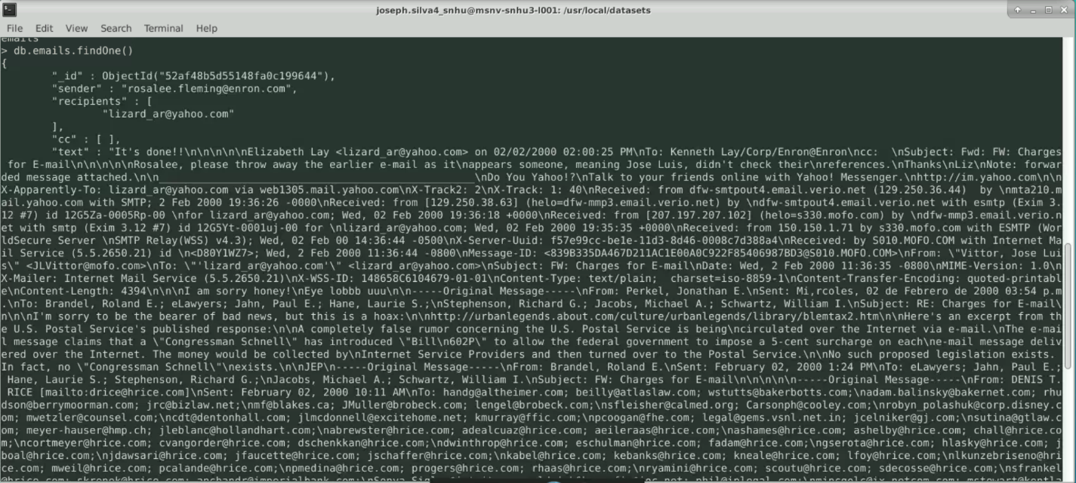

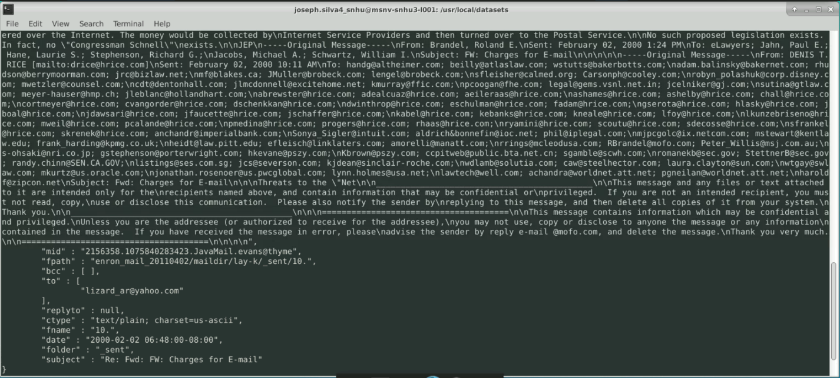

* **Size of a single Document**

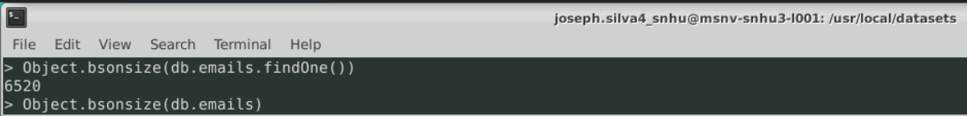

* **Size of collection of documents**

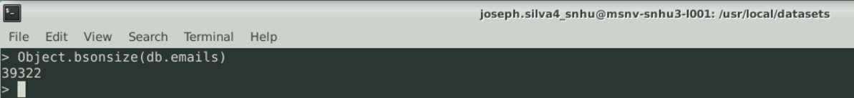

* **exit**

